[Mars | Room Management System by t1m9m | CodeCanyon](https://codecanyon.net/item/mars-room-management-system/21646390)

**Boarding House Management System**

**Front-end Website**

**Login Form**

**Admin Dashboard**

* Number of Tenants
* Number of Rooms
* Number of Beds

**Tenants Profile**

* Last name
* First name
* Middle name
* Complete Address
* Email Address
* Contact Information
* Gender
* Profile Picture
* Proof of Identity - upload

**Room Management**

* Room Number
* Description
* Image

**Bed Management**

* Bed Number
* Room Number
* Daily Rent
* Monthly Rent
* Bed Status – available, occupied

**Bed Assignment**

* Tenant Name
* Room Number
* Bed Number
* Date Started
* Due Date

**Water Bill Rate**

* Rate

**Electricity Bill Rate**

* Rate

**Invoice** – Print after encoding

* Invoice Number
* Tenant
* Room Number
* Room Rate
* Electricity Bill
* Water Bill
* Total Due
* Year
* Month
* Remarks
* Status – Paid, Unpaid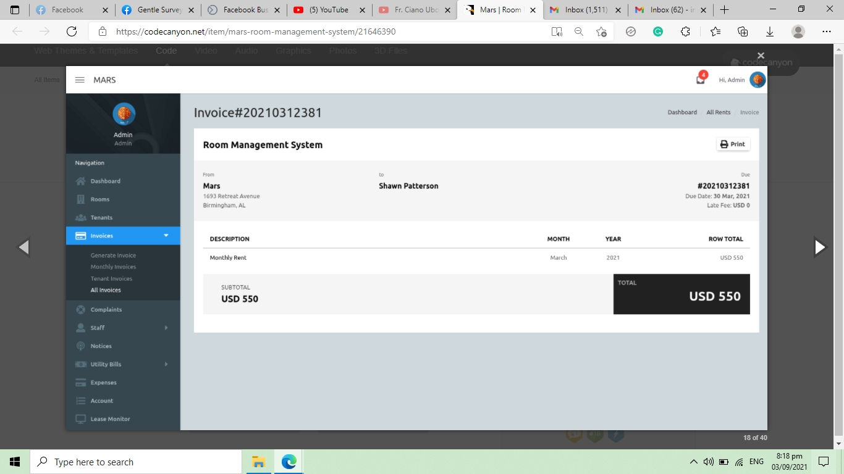

**Payment History**

* Invoice Number
* Amount Paid
* Date of Payment
* Remarks

**Payment Sent by Tenant** – view and update status

* Payment Amount
* Date
* Proof of Payment
* Remarks
* Status – approved, pending, disapproved

**SMS Configuration** - via iTexMo API

* API Code
* API Password
* Set Alarm - set number of days before the due date
* Message

**Notice Board**

* Title
* Notice Body

**Suggestions From Tenants** – view and reply only

* Tenant name
* Suggestion/recommendations
* Date
* Reply from owner
* Status – pending, solved, on-going

**Income Report** – filter by date range

**Collectible per tenant**

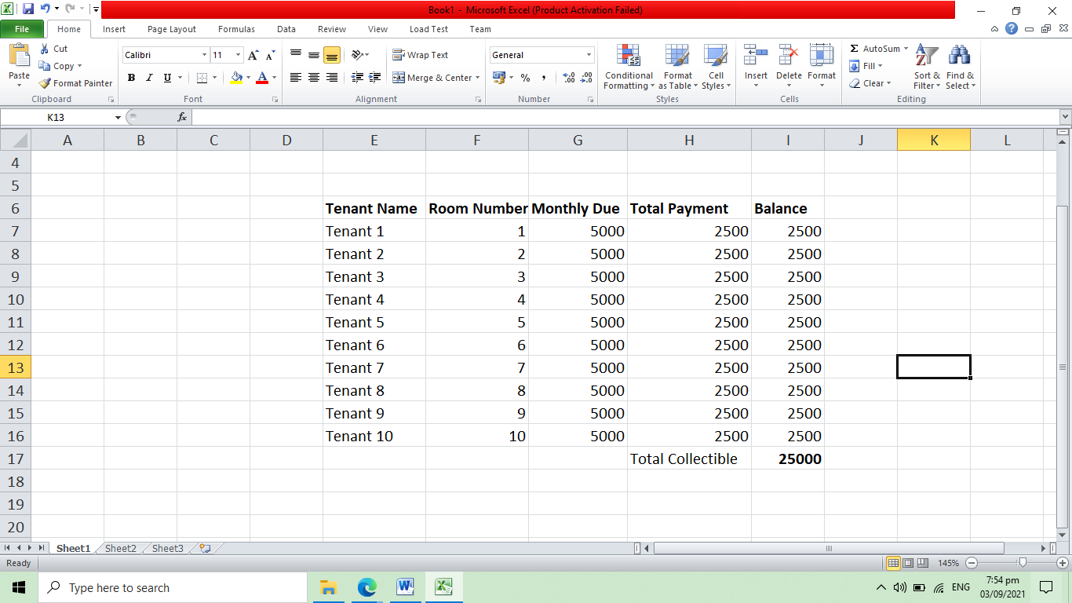

**TENANT ACCOUNT**

**Dashboard**

* View Balance
* Check Payment History

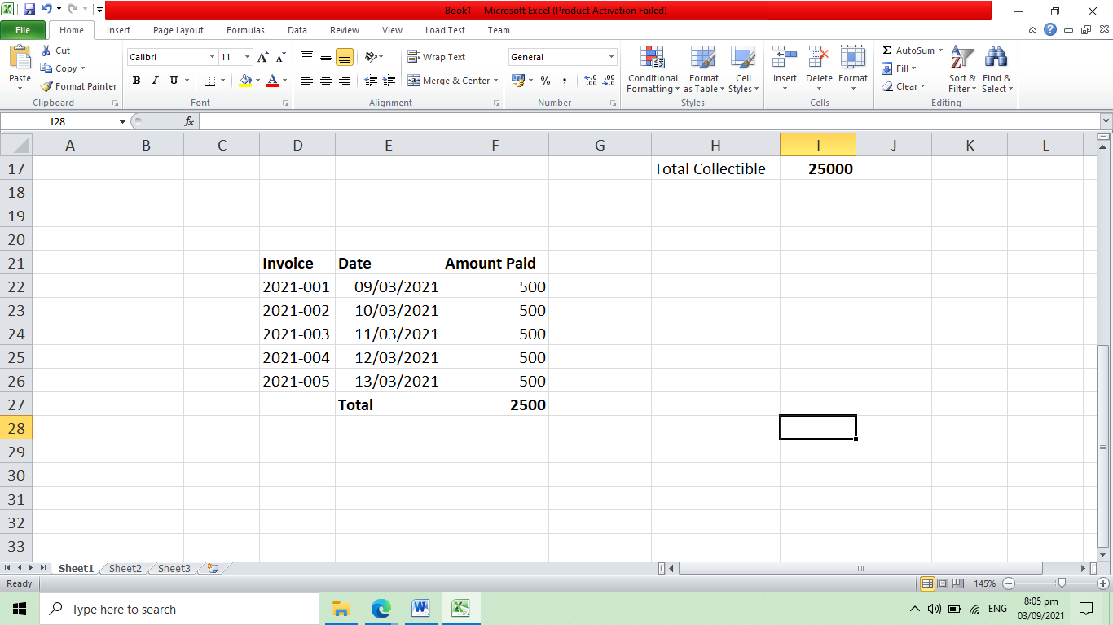

**View Notice Board**

**Submit Suggestion/Recommendation/Complaint – Add, Update and Delete**

* Tenant name
* Suggestion/recommendations
* Date
* Reply from owner
* Status – pending, solved, on-going

**Submit Proof of Payment – Add and Update**

* Payment Amount
* Date
* Proof of Payment
* Remarks
* Status – approved, pending, disapproved